**­­­How to Write an Email for B1 Preliminary (PET)**

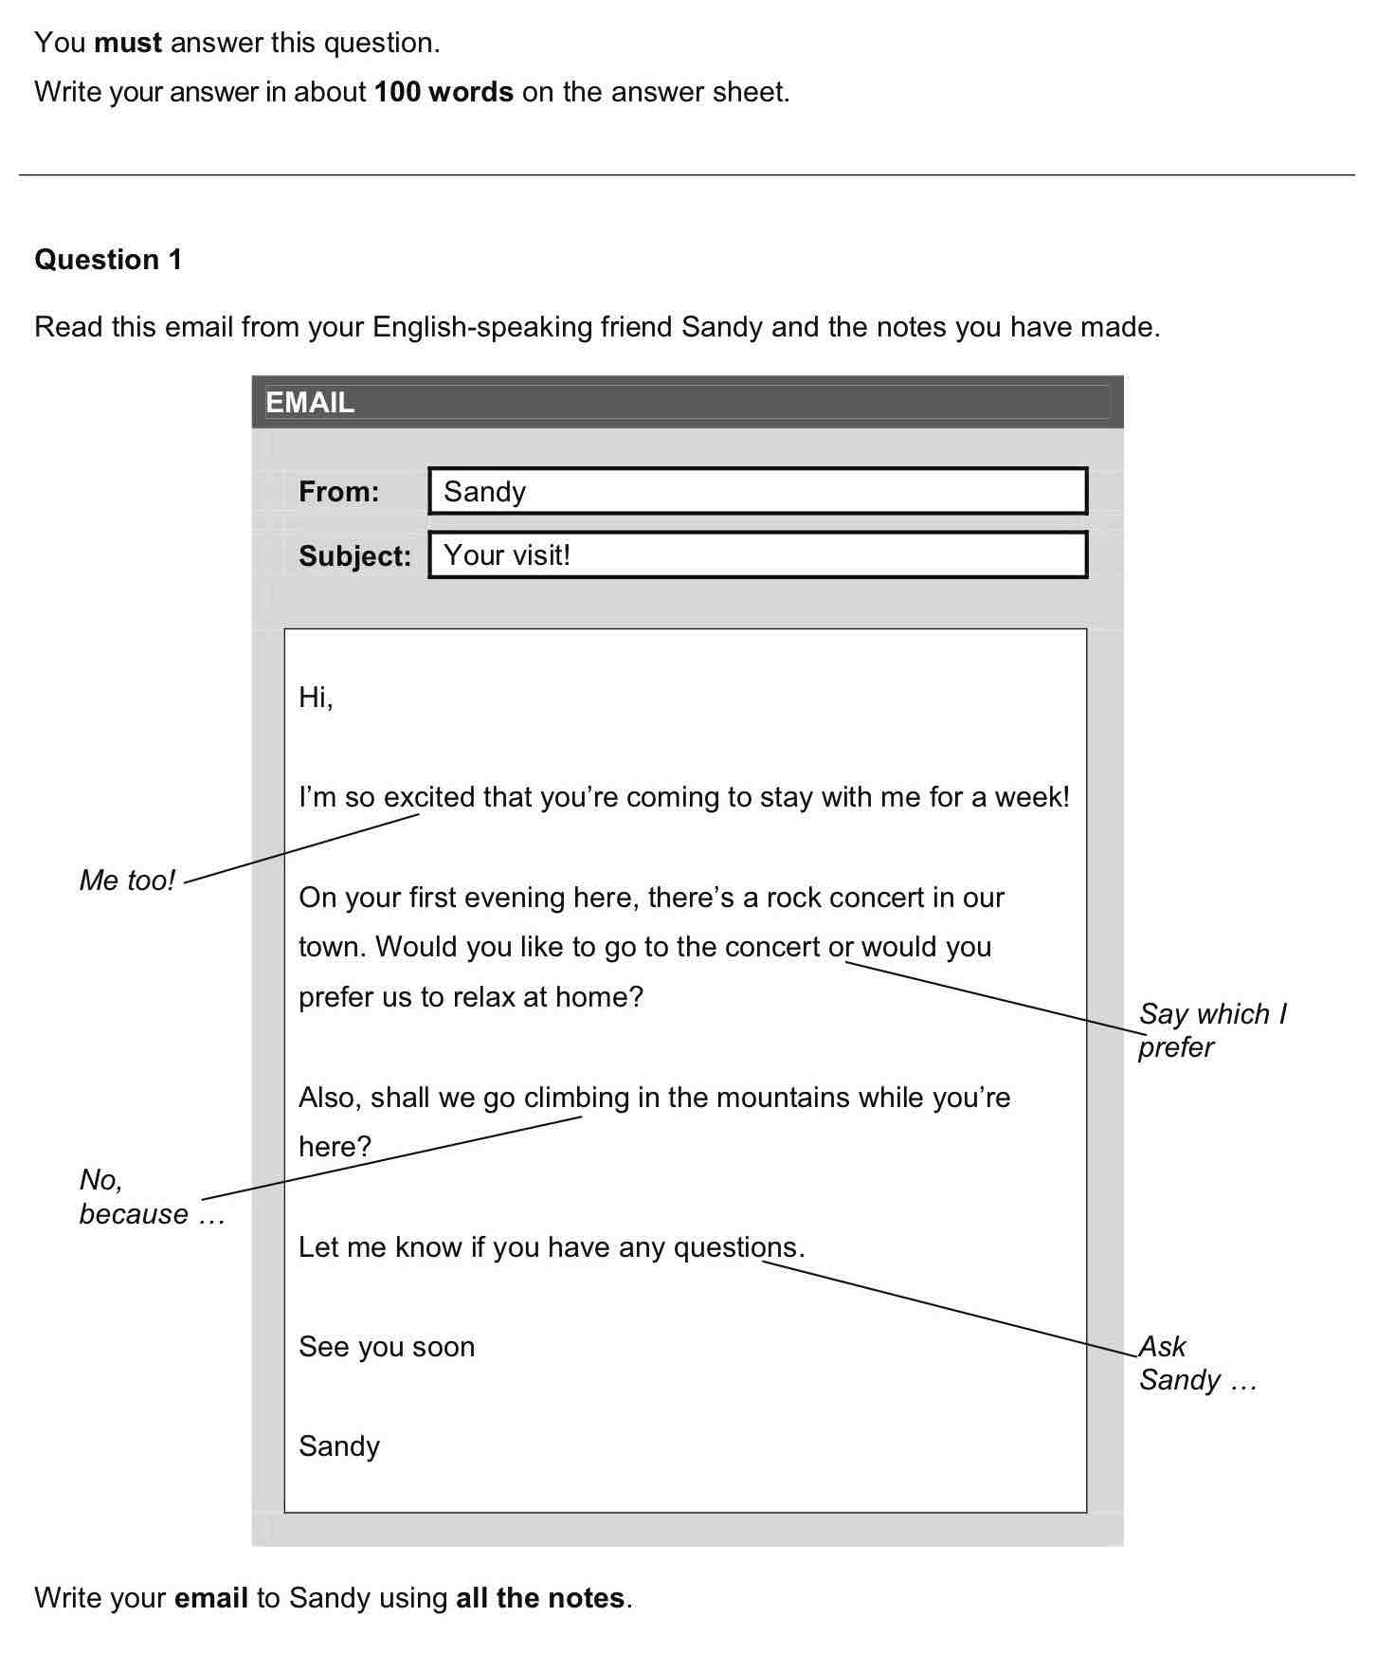

As you can see in the example above, taken from Cambridge’s official website, we have received an email from a person so-called *Sandy*, who is a friend of ours. In addition, we have made some annotations, which are the points we need to address in your email:

* *Me too!*
* *Say which I prefer*
* *No, because…*
* *Ask Sandy…*

In this sense, Cambridge is making this task easier, as we definitely won’t go blank and they are pointing out **the structure that our email should have**, which we will see in the following section.

**Email structure**

The first thing you need to know is **the different parts of an email**, and these are:

* **Greetings:** we *greet* the other person (i.e. say «hi» or «hello»).
* **Opening paragraph:** we react to the other person’s news and ask them how they are feeling and whatever else you feel is appropriate.
* **Main paragraph 1:**in this paragraph we deal with the first important point, which we can identify in the instructions.
* **Main paragraph 2:** if there is a different point to deal with, this paragraph will do so.
* (We might have more main paragraphs, depending on the task.)
* **Closing paragraph:** in this paragraph we «start» to say goodbye by wishing the other person well and asking them to reply to your email.
* **Goodbye:** we use a short expression to say goodbye.
* **Signature:** we sign the email with our name.

In general, all emails must follow the same structure, and also, I recommend you following these two pieces of advice::

* **Don’t write *From:* y *To:****,*as it is completely unnecessary and Cambridge won’t penalise you. Also, you’re saving words which you can use in the body of your email.
* **Don’t write a *subject***, for the same reason as before.

Now that we know the different parts of an email, we should see an example.

**Example Email for PET Writing Part 1**

Let’s take a look at the following **example of a Preliminary (PET) task answer for Writing Part 1**, where we can see an answer to the sample task we saw above:

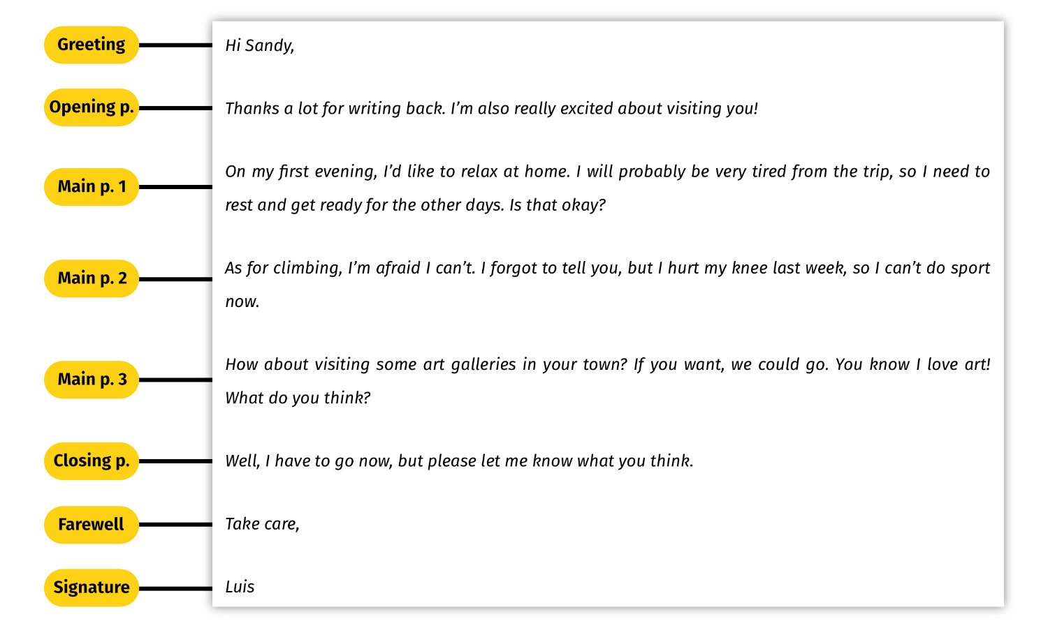

In the example above, you can see **the different parts of an email** well defined. **It’s important that your writing is visually appealing**, apart from having good grammar and vocabulary. This means that **the paragraphs should be well defined**, with a space in between, and that you should know when to break lines. This is specially important after greetings, after opening and closing paragraphs, and after saying goodbye. This will make your text visually appealing, as it will look like a real email.

**Expressions to use in your email**

In this section, we are going to focus on **different expressions you can use in the different parts of the email**. While the main paragraphs will vary completely depending on the topic of your writing, most of the other parts in the email can be practised and memorised almost completely. Let’s take a look:

**Greetings**

In order to start your **email in Writing Part 1 for Cambridge English: Preliminary (PET)**, you can use different expressions, which are really typical and easy to remember. We have 3 basic ways to greet in this kind of writing, which is usually for a friend or family member:

* *Hi John,*
* *Hello John,*
* *Dear John,*

Notice how «hi» is less formal than «hello» or «dear». Also, **don’t forget to write a comma (,)** right after greeting your friend or relative. After greeting the addressee (i.e. the person who will read the email), you must start **the opening paragraph in a new line**.

**Opening paragraph**

The opening paragraph is the place to **react to your friend’s or relative’s email**. In order to do so, you can use a number of different expressions. Here we have some examples:

* *It’s nice / great / good to hear from you.*
* *It’s nice / great / good  to read your email.*
* *I’m glad to hear your news.*
* *I’m excited about…  (your news.)*
* *It’s great to hear that…*
* *I’m sorry to hear that…*
* *I’m really sorry to read your news.*
* *Thanks a lot for writing!*
* *It was good to receive your email.*
* *Thank you very much for your email.*

And many more. Also, it’s a good idea to **ask your friend or relative how they are feeling**, which you can do like this:

* *Hope you are doing well.*
* *How’s it going?*
* *How are you (doing)?*
* *How are things (going)?*

You can also add some information that you think is relevant or necessary, but don’t expand this paragraph very much, because **the important information must go in the main paragraphs**.

**Main paragraphs**

For the main paragraphs, there aren’t any fixed expressions which you must use, as it depends mostly on what you have to write about. However, you should try to **make use of connectors and appropriate punctuation**. So let’s take a look at [**common useful connectors**](https://kseacademy.com/conectores-ingles-b1/)**and the punctuation** we use them with:

* *… and…*:  to connect two similar things or ideas.

*I love reading****and****listening to music.*

*My favourite meal is fish****and****chips.*

* *…, but…* : to connect two contrasting ideas.

*I love watching Tv****, but****I don’t have a favourite show.*

*I am reading a book,****but****I don’t remember the title.*

* *. However, …* : to connect contrasting ideas.

*Last month, I went to the cinema****. However,****I didn’t enjoy the movie.*

*I am a very big fan of this author****. However,****I haven’t read his last novel.*

* *Moreover, …* : to add more information about something.
* *… because…* : to justify an opinion or idea.

*My mum is the perfect cook****because****she knows a lot of recipes and has plenty of experience.****Moreover,****she experiments with different ingredients all the time.*

* *. Because of that, …* : to justify an opinion, fact or idea.

*My mum likes to cook using new ingredients all the time.****Because of that,****she creates original dishes every month.*

* *. As for…/ Regarding…*: to switch to a new topic. For instance, you can use this connector to start the second main paragraph.

***As for/Regarding****why I like this cookery show, I think it’s because it’s a great way to see new recipes.*

* Time linkers: *then, after that, yesterday, this morning, last summer, etc.*

***Last night,****I watched a very good action film.*

With many connectors, we typically use a comma (,) after it when we start a sentence (e.g.: *However, Last night, Moreover, etc.*).

**Closing paragraph**

As we mentioned earlier, a closing paragraph in this Writing part 3 is used to start saying goodbye to the addressee and to ask for a response to your email. So we can use the following expressions:

* *Well, it’s time to say goodbye.*
* *Anyway, I have to go now.*
* *Well, it’s time to go.*
* *Anyway, gotta go.*
* *I really hope to hear from you soon.*
* *I’m looking forward to hearing from you.*
* *I hope you write back soon.*
* *Make sure you write back soon.*

Also, if you still have to write more words, **you can add a question** for a subsequent email. This question should be related to the topic of your piece of writing.

**Saying goodbye**

There are many ways in English to close an informal email. The most frequently used ones are the following:

* *Best wishes,*
* *Best,*
* *Sincerely,*
* *Take care,*
* *All my love,*
* *Love,*
* *Lots of love,*
* *See you soon,*
* *Regards,*

Notice how **there is a comma (,) after each of the phrases**. Also, after writing any of these sentences, make sure you **write your name on a different line**. And write your name without a full stop!

**Another example of an email at B1 level**

Now that we know what expressions we should be using in our writing, we are going to take a look at another task and a sample answer. In this case, this is an example of an old task, but the email follows the same rules. Pay close attention to how it’s structured and how its paragraphs are well defined and separated:

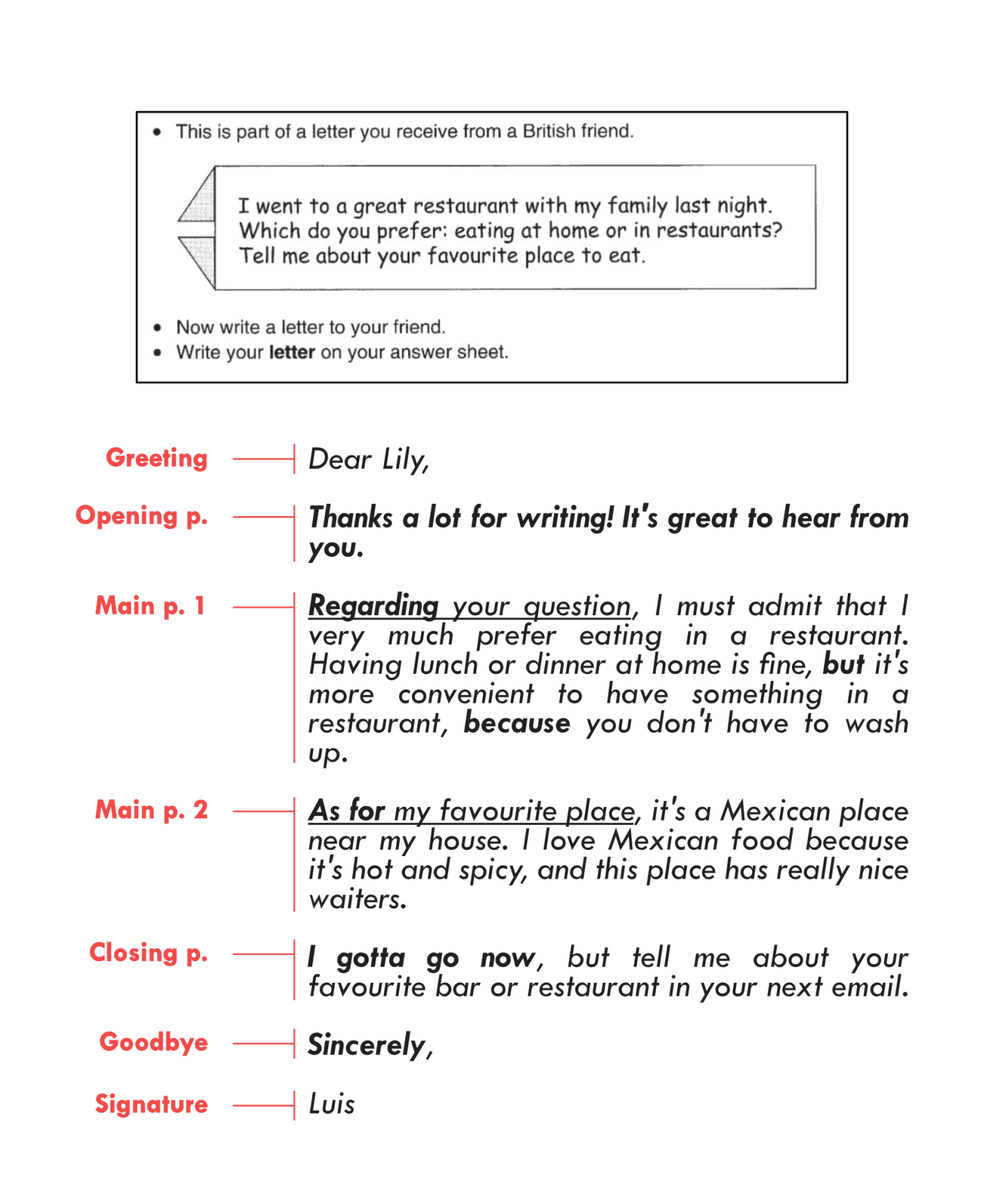

Notice how the expressions in **bold** are used. Whenever you write an email, you should think about this type of expressions and **make sure you use them appropriately**.

**Top 5 Tips for writing an Email for B1 Preliminary (PET)**

1. **Learn and memorise a set of expressions**. Make sure you already know a set of expressions to use in your greetings, opening and closing paragraphs, and to say goodbye. This will save you a lot of time while doing a task, and you will avoid making silly mistakes as you will already know the expressions by heart.
2. **Write a well-structured and visually-appealing email**. One of the things Cambridge English examiners pay attention to is the organisation of your piece writing, so make sure not to write a messy email. Also, remember that **punctuation matters**, so be sure to separate your sentences with stops and commas and don’t write excessively long sentences.
3. **Brainstorm, write, read and edit**. Before starting to write your email, brainstorm a couple of things and write down some ideas. This can include vocabulary related to the topic. For example, if you have to write about TV shows, you can write down thinks like «contestants», «cookery show», «prize», etc. Then, write out your email. After that, read it and look for possible mistakes or opportunities for improvement (e.g.: adding descriptive adjectives, rephrasing sentences, etc.).
4. **Read carefully and identify the task**. Don’t start writing right away. Make sure you read the task carefully and that you identify exactly what you are being asked. Sometimes, we don’t pay attention to the instructions and we end up writing about something different. This will mean losing points, in a very silly way, I must say.
5. **Experiment at home, be conservative in the exam**. Homework is the best chance to be creative and experiment different ways to express yourself. So make sure you try your hardest to keep improving when you write at home. On the other hand, when you’re doing an exam, don’t risk trying out new words or expressions, as you may be making a terrible mistake. So be safe in your exam and **stick to what you already know works**.